1. The values that were found are
   1. Average = 18, Standard deviation = 8.5154
   2. The average remained the same however, the standard deviation changed a bit and became 8.6268. The average value did not change because the last value was 18 itself. So removing the number itself from the list would not affect the mean. However, the small change in the standard deviation means
2. The threshold value that was found was 21.
   1. The best age to use is 21
   2. The mixed variance that was resulted is 22.9545.
   3. I would take the ‘lowest’ value or the one that appeared first.
   4. Other methods that can be used are:
      1. Vector quantization
3. The value that caused the best splitting point to change and resulted in the best mixed variance was 1/1000. It was observed that as the value of the number decreased from largest to smallest, the mixed variance value started to get smaller to the near correct value.
4. The circular point has been clearly added to the point x = 21 and y = 22.95

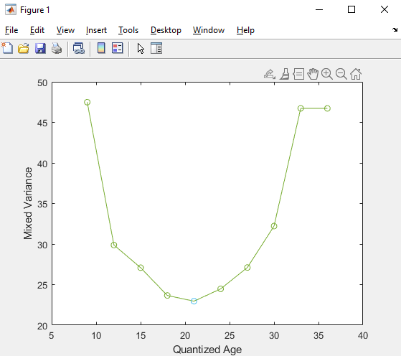

1. By performing the experiment for this lab, I was especially impressed by the working of Otsu’s method as it had now been done practically. It was relatively easy as the algorithm had already been mentioned to us. I wanted to see the change of data being done so I printed out all the values as the change took place. I was able to actually see the data being changed in order to find the lowest value which got me a bit more interested. After I had plotted the values and saw the result was making sense, I had thoroughly understood the algorithm.